Gravitational Potential Energy
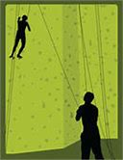
Gravitational Potential Energy (GPE) is the amount of energy an object has because of its position above the ground, i.e. its height.
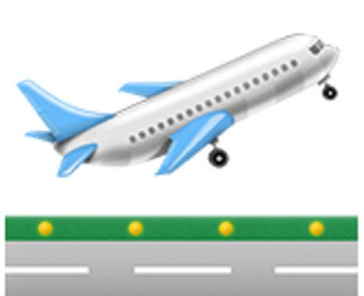
When you go up, your height increases so you gain GPE.
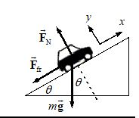
For example, if you…
- climb a wall,
- drive up a hill,
- take off in a plane or
- take an elevator up
If you gain height you gain Gravitational Potential Energy. The opposite is also true. When you lose height your gravitational potential energy decreases because it is converted to other forms of energy (usually kinetic energy).

Gravitational Potential Energy is often referred to as GPE, and sometimes as E_{P}.
When you lose height you lose GPE.
When an object is on the ground. it has zero GPE. (GPE = 0)

Calculating GPE - We can calculate GPE (E_{P}) using $GPE=mass x gravity x height$
GPE
m x g x h
There are 3 ways or writing this formula
$GPE=m x g x ht$ OR $ht=\frac{GPE}{m x g}$ OR $m= \frac{GPE}{g x ht}$
Remember that
- Mass must in kilograms (kg).
- Gravity is usually taken as 9.8 m/s/s on Earth (g = 9.8).
- Height must be in metres (m).
- GPE must be in joules (J).
Examples
- A boy has climbed a tree and is 4.3 metres above the ground. He weighs 56 kilograms. What is his gravitational potential energy?

- A cricketer throws a ball straight up. If the ball had a mass of 200g and the cricketer was able to give the ball 64 J of energy, how high did it go?

- A bird is flying at a height of 45 metres and has 960J of G.P.E. What is the mass of the bird?
Harder questions.
This is where it gets complicated…
Consider the bird in question 3 – flying along at 45 metres high. Say the bird dives and loses height. If it loses height it must lose GPE… it loses energy… so where does that energy go????
ANSWER – the energy is not lost – it is converted into another type of energy – called kinetic energy. Kinetic energy is “moving” energy so it sort of makes sense… when thing fall they move faster… so the loss in GPE (potential energy) is equal to the gain in Kinetic (moving) energy. The opposite is true when things go up – kinetic, or “moving” energy is put in and converted into the Gravitational Potential Energy which increases as thing go up in height.
For Example
A diver who has a mass of 75 kg is standing on top of a 12m cliff over the ocean. If she dives off the cliff, what speed will she be travelling when she hits the water?
Think – You have all the information to calculate the GPE for the diver at the top of the cliff. But you have no information which would allow you to calculate speed or velocity when the diver hits the water. How can you do this problem?
The trick is to realise that the KE formula has speed/velocity in it (KE = ½ x m x v²), so you can calculate speed/velocity from KE if you know it. When the diver fell, all that GPE that was there has been converted to KE by the time she hits the water. So the lost GPE has become KE. Thus you can know KE by calculating GPE.
Extra step – Calculate GPE using the information in the question (m and ht)
Extra step – make KE equal the GPE which has been lost. Since the diver fell all the way down, all the GPE has become KE, so GPE = KE.
Normal problem solving process – Use your new value for KE, and the KE formula to calculate the speed/velocity.
Show your working here

Extension: If the diver hit a rock which was 7 meters from the top of the cliff, what would be the speed/velocity with which she hit the rock?

Questions to check your understanding

Determine whether the objects in the following problems have kinetic (KE) or potential energy. (PE). Then, use the appropriate formula to calculate the answer.

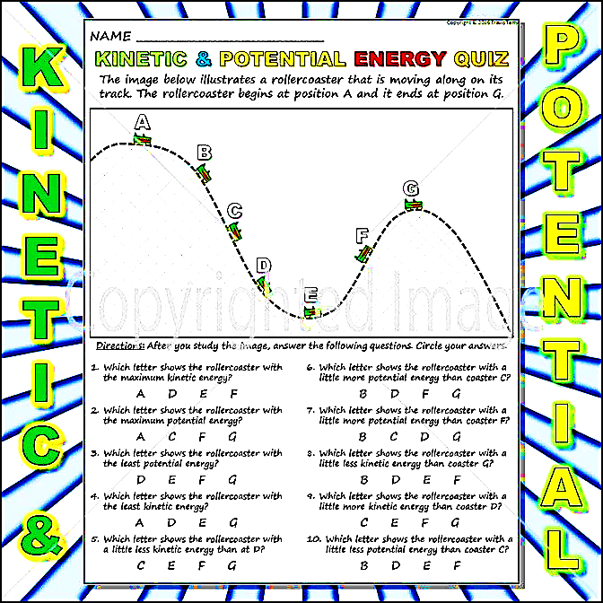

- You serve a volleyball with a mass of 2 kg. The ball leaves your hand with a speed of 30 m/s. Calculate the kinetic energy of the ball.

- A baby carriage is sitting at the top of a hill that is 20 m high. The carriage with the baby in it weighs 10 kg.
a. Calculate the potential energy of the baby carriage.

b. Calculate the speed of the carriage if it rolled down to the bottom of the hill.

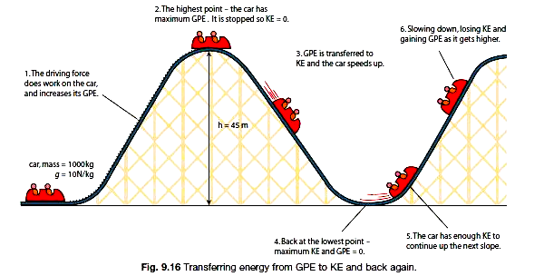
- Roller coaster are great examples of Potential and Kinetic energy
C
B
A
For the roller coaster shown above
a. Calculate the Gravitational Potential Energy when the roller coaster is at its highest point (A).

b. Calculate the speed of the roller coaster when it has fallen to its lowest point (B).

c**. When the roller coaster is at point C, it has a velocity of 5 metres/sec. How high is the rollercoaster of the ground?

